CS 340 Project Two README
  - Grazioso Salvare Interactive Rescue Dashboard
Robert Cardoza | CS-340 | Project Two

About the Project / Project Title
Grazioso Salvare Interactive Rescue Dashboard
Project Two builds on the reusable AnimalShelter CRUD Python module developed in Project One. The completed application uses a MongoDB database of Austin Animal Center outcome records and a Python Dash dashboard to help Grazioso Salvare explore dogs that match rescue-training profiles. Users can select a rescue category, inspect matching records in an interactive data table, compare breeds in a pie chart, and view a selected animal’s location on a map.
The database layer remains separate from the dashboard code. The AnimalShelter class from Project One provides reusable MongoDB access, while Dash callbacks update the visible results when users change the rescue filter. This approach extends the original CRUD foundation rather than replacing it.

Motivation
Grazioso Salvare needs an approachable way to review shelter records and identify dogs for water rescue, mountain or wilderness rescue, and disaster or individual tracking. A dashboard makes the information easier to explore than running database commands manually. Radio-button filters reduce the need for users to understand MongoDB query syntax, while the table and visualizations provide multiple ways to examine the same results.

Getting Started
The project was developed in the course-provided Codio environment using JupyterLab. The primary project files are ProjectTwoDashboard.ipynb and CRUD_Python_Module.py. The dashboard also uses the Grazioso Salvare logo image and the Austin Animal Center Outcomes CSV dataset. Keep the notebook and Python module in the same working directory so the notebook can import AnimalShelter.
The MongoDB database is named aac and the collection is animals. The working dataset was reimported and verified to contain 10,000 records. The application uses the existing aacuser account for the Python database connection. The notebook code must be configured with credentials appropriate to the environment; do not publish real credentials to a public GitHub repository.

Installation
The main tools are Python, MongoDB, PyMongo, Dash, Plotly, Pandas, Jupyter Notebook, and Codio. MongoDB stores flexible JSON-like animal records and supports field-based queries and indexes. PyMongo exposes those queries to Python through MongoClient, allowing the existing AnimalShelter.read() method to retrieve records without embedding database commands throughout the dashboard. Dash supplies the web interface, interactive controls, and callback-based controller logic. Plotly supplies the breed distribution pie chart; the map visualizes geolocation information.
For a local Python environment, install the packages used by the notebook (versions should be selected to match the code and environment):
python -m pip install pymongo dash pandas plotly jupyter jupyter-dash
The Codio environment may already contain these packages. The dashboard notebook also needs access to its logo file and a running MongoDB service.

Usage
Open ProjectTwoDashboard.ipynb in JupyterLab and run the cells in order. The starting dashboard shows the Grazioso Salvare logo, creator identifier, rescue-type radio buttons, a paginated data table, a breed distribution pie chart, and a geolocation map. Choose a rescue type to retrieve the matching dogs. Choose Reset (Show All Animals) to return to the full collection.

Filtering options
- Water Rescue: Filters for the preferred water-rescue breed group and specified profile criteria.
- Mountain or Wilderness Rescue: Filters for the preferred mountain/wilderness breeds and specified profile criteria.
- Disaster or Individual Tracking: Filters for the preferred disaster/tracking breeds and specified profile criteria.
- Reset (Show All Animals): Removes the rescue-category filter and restores the unfiltered table and visualizations.
The table can be browsed by page and displays animal fields such as animal ID, type, breed, age, outcome, and coordinates. The pie chart recalculates breed proportions from the filtered results. The geolocation map responds to the available data and selected animal. The displayed records represent database matches, not a final determination that a dog is suitable or available for training.

Code Example
The following illustrates the reuse of the Project One module to retrieve records for a dashboard query. The exact rescue filter dictionaries remain in ProjectTwoDashboard.ipynb.
from CRUD_Python_Module import AnimalShelter

# Supply the database credentials required by the environment.
shelter = AnimalShelter()
all_animals = shelter.read({})
water_dogs = shelter.read({"animal_type": "Dog"}) # Simplified example
In the completed notebook, Dash callbacks use the selected radio value to construct the full rescue-specific query, call the CRUD module, and update the table. Other callbacks use the resulting data to update the pie chart and map.

Tests
The dashboard was tested in Codio by running the notebook and changing each rescue-type option. The initial and reset states display the unfiltered animal collection, while the three rescue filters return smaller matching groups. The screenshots below show the table and breed chart responding to these selections, along with the geolocation map. The MongoDB collection was also checked after reimporting the CSV, and indexes were recreated for animal_type and a compound group of commonly queried fields.
One challenge was inconsistent or duplicate records during testing. Reimporting the dataset with --drop restored the intended collection contents, and the database count was checked before rerunning the dashboard. Another challenge was coordinating the dashboard filters and charts so they refreshed together; testing each radio option and Reset confirmed the visible widgets changed as expected. The project also required keeping the notebook, CRUD module, logo, and database connection configured consistently.

Screenshots
The following captures document the dashboard states requested by the Project Two rubric. Each screenshot includes the Grazioso Salvare logo and the dashboard creator identifier.

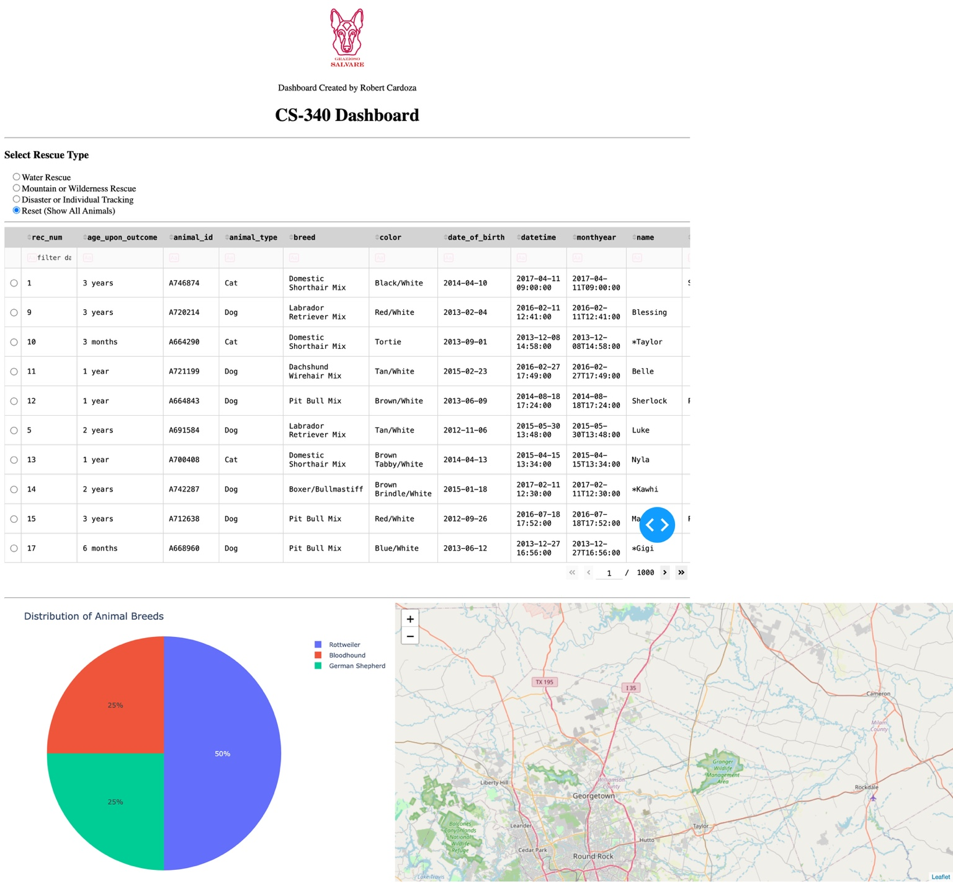
Figure 1. Initial dashboard state with Reset selected: unfiltered table, breed chart, and map.

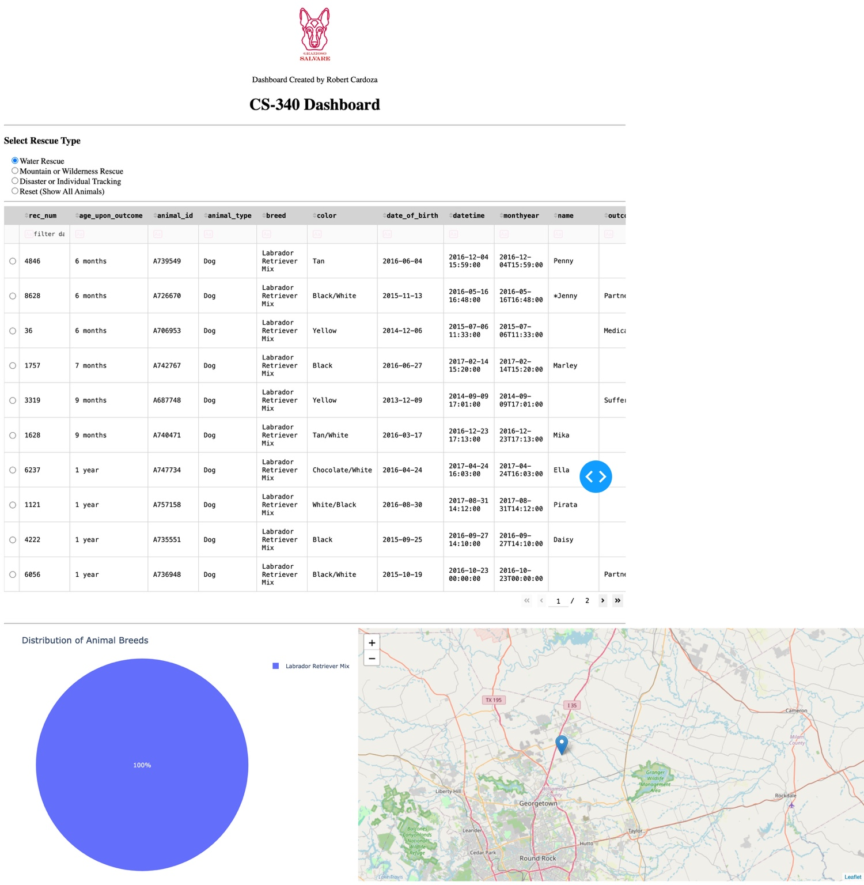
Figure 2. Water Rescue filter applied: matching records and updated visualizations.

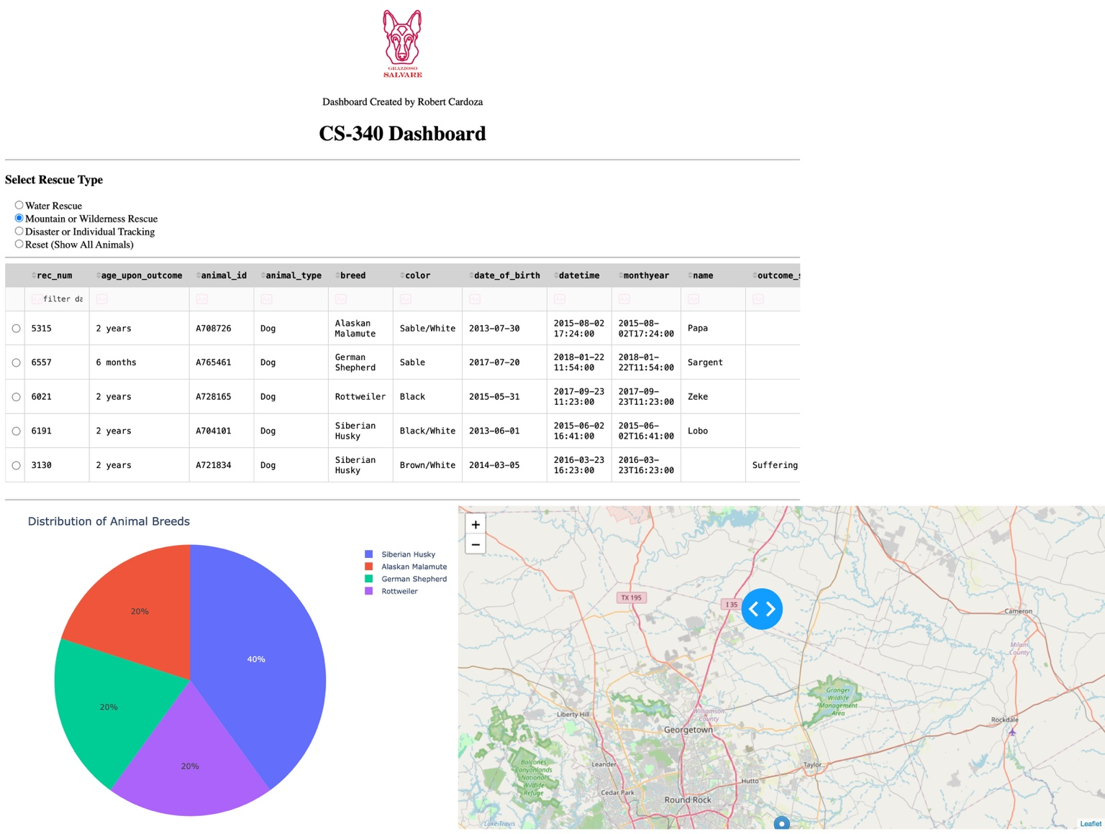
Figure 3. Mountain or Wilderness Rescue filter applied.

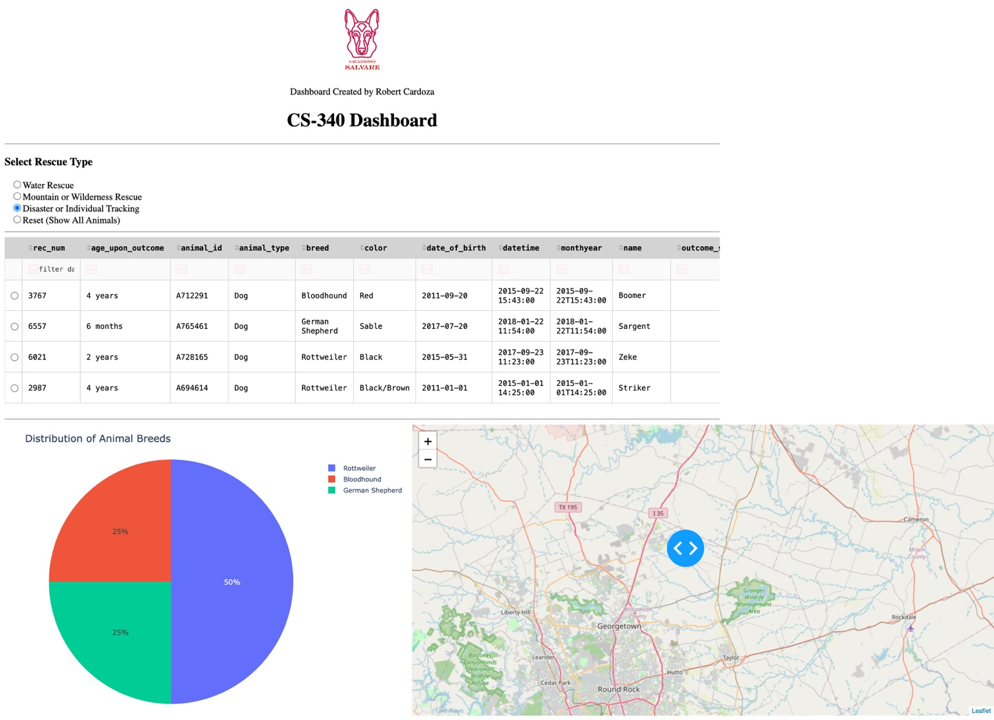
Figure 4. Disaster or Individual Tracking filter applied.

Figure 5. Reset selected again to restore the unfiltered dashboard.

Reproduction Instructions
- Obtain ProjectTwoDashboard.ipynb, CRUD_Python_Module.py, the Grazioso Salvare logo, and the course-provided Austin Animal Center Outcomes CSV dataset.
- Start MongoDB and create or select the aac database. Import the CSV into the animals collection, using --headerline to recognize field names.
- Confirm the imported record count and create the required MongoDB account and indexes if they are not already configured.
- Install the Python dependencies and verify that the notebook can import the AnimalShelter class from CRUD_Python_Module.py.
- Configure the database connection for the local MongoDB host and an authorized account. Keep secrets out of public source control.
- Launch JupyterLab, open ProjectTwoDashboard.ipynb, and run all cells in order to start the dashboard.
- Test Water Rescue, Mountain or Wilderness Rescue, Disaster or Individual Tracking, and Reset. Confirm that the table, pie chart, and map respond appropriately.
Example CSV import command (adjust the dataset path for your environment):
mongoimport --type=csv --headerline --db aac --collection animals --drop datasets/aac_shelter_outcomes.csv
Example MongoDB verification and indexes in mongosh:
use aac
db.animals.countDocuments({})
db.animals.createIndex({ animal_type: 1 })
db.animals.createIndex({ animal_type: 1, breed: 1, sex_upon_outcome: 1, age_upon_outcome_in_weeks: 1 })

Roadmap / Features
Possible future improvements include clearer indicators of how many animals match each filter, additional search fields, improved mobile layout, and a dedicated deployment configuration. Before using the dashboard in a real rescue program, the team should also confirm data freshness, candidate availability, and the exact screening requirements with Grazioso Salvare.

Resources
- MongoDB documentation — https://www.mongodb.com/docs/
- PyMongo documentation — https://pymongo.readthedocs.io/
- Dash documentation — https://dash.plotly.com/
- Plotly Python documentation — https://plotly.com/python/
- Pandas documentation — https://pandas.pydata.org/docs/
- Jupyter documentation — https://docs.jupyter.org/

Contact
Robert Cardoza | CS-340

